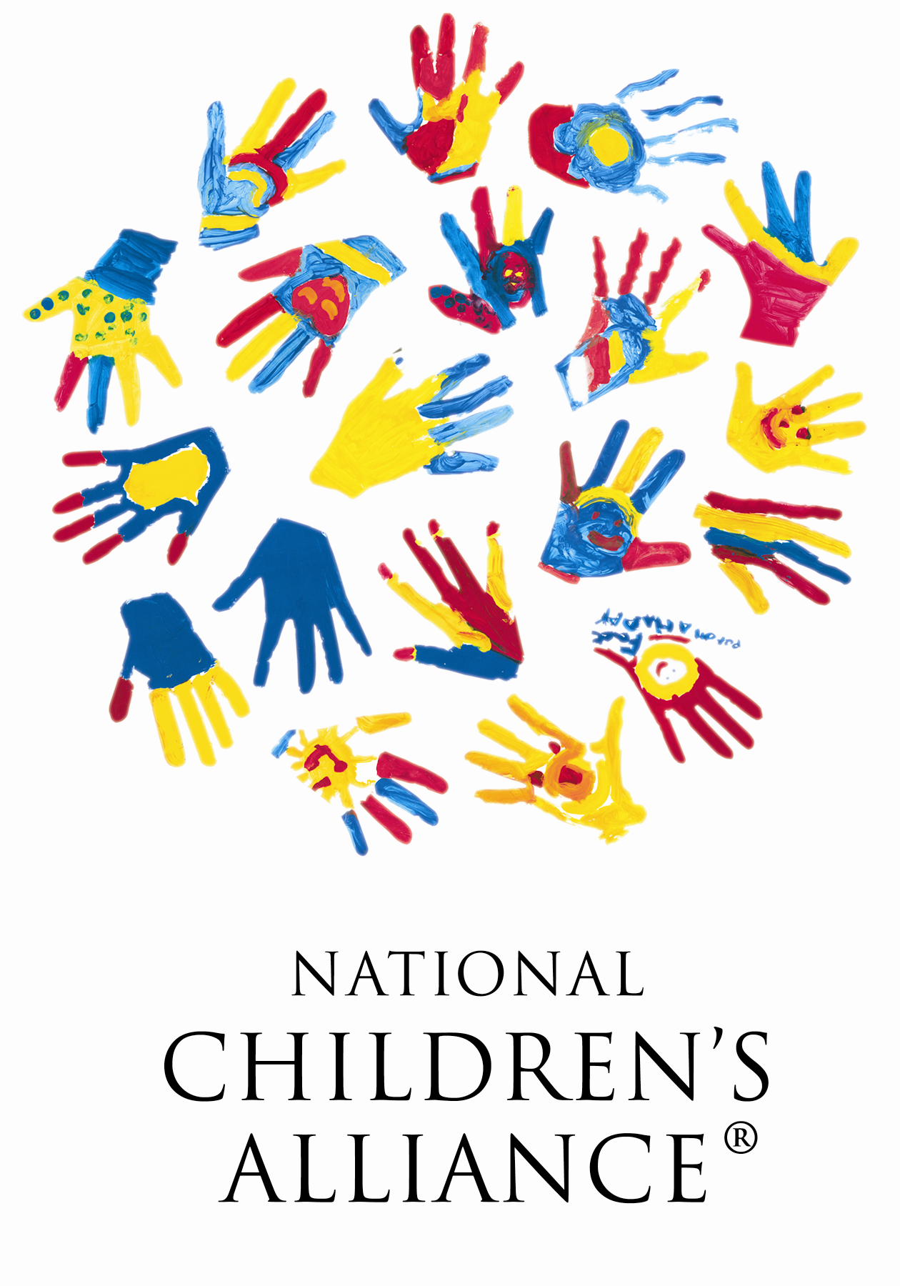
National Children’s Alliance
Application for Satellite Membership with NCA

HOST AGENCY INFORMATION

Host Agency’s Name:
By checking this box, I certify that our agency is currently an accredited member of the National Children’s Alliance in good standing.
Host Agency’s Authorized Representative Name:
Host Agency’s Authorized Representative Title:
Host Agency’s Board President:
Host CAC Information:
Physical Address:
Mailing Address:
Phone Number: Fax Number:
Email Address: Web Address:
Note: The above email address will be used for all general communication with the center.

SATELLITE AGENCY INFORMATION

Satellite Agency’s Name:
Satellite Agency Authorized Representative’s Name:
Satellite Agency Authorized Representative’s Title:
Satellite Agency Advisory Board President’s Name (if applicable):
Satellite Agency Information:
Physical Address:
Mailing Address:
Phone Number: Fax Number:
Email Address: Web Address:

SATELLITE AGENCY INFORMATION

Applying for:
Satellite Membership (New) Satellite Membership (Renewal)

Current Membership Status of the Satellite Agency:
Accredited
Associate/ Developing
Affiliate
Non-member

Population of area served:
What is your Satellite’s organizational structure? (Check one)
Child Protective Services/Government Based CAC
Hospital Based CAC
Prosecution/ Government Based CAC
Law Enforcement/ Government Based CAC
Independent Non-profit 501(c)(3)
Program under umbrella of a larger non-profit 501(c)(3)
Other (please specify)

Our Satellite CAC program budget is:
Note: If you are part of an umbrella organization such as hospital, county, etc. please, enter the budget specific to your Satellite only.

HOST AGENCY INFORMATION

Population of area served:
What is your CAC’s organizational structure? (Check one)
Child Protective Services/Government Based CAC
Hospital Based CAC
Prosecution/ Government Based CAC
Law Enforcement/ Government Based CAC
Independent Non-profit 501(c)(3)
Program under umbrella of a larger non-profit 501(c)(3)
Other (please specify)

Our CAC annual budget is:
Note: If you are part of an umbrella organization such as hospital, county, etc. please, enter the budget specific to your CAC only.

APPLICATION VERIFICATION

We, the undersigned designated legal representatives of the Host CAC and the Satellite Agency, affirm that the information contained and represented in this National Children’s Alliance Application for Satellite Membership is a true representation of the operations and programming of this Children’s Advocacy Center and its multidisciplinary team. We understand that any misrepresentations may result in a denial of membership or a revocation of said membership if discovered after it has been awarded.

Authorized Host Agency Representative:

Host Agency Board President:

Satellite Agency Authorized Representative:

Satellite Agency Advisory Board President (if applicable):

