NCA Statistical Data Submission Instructions

All Accredited, Associate/Developing and Satellite* Members are required to submit a center/agency statistical report to NCA every six months in order to comply with membership requirements and to remain in good standing.

NCA uses these statistics to report to the Department of Justice, and respond to Congressional inquiries, as well as in our annual report. They are our tools for discussion at the local, state, and federal level. So that we can best represent the good work that is taking place in CACs across the country, please report your statistics as accurately as possible.

The Submission Process
Step 1: Log in to the system
- For Current NCAtrak users: Please submit your report through your NCAtrak account.
- For all other submitters: Please go to https://www.ncatrak.org using any of the following web browsers: IE 11, Chrome, Firefox, Edge or Safari. (See Appendix A for more information about setting up IE 11..)
- Important: No faxed, mailed or emailed forms will be taken under consideration.
The Login Screen
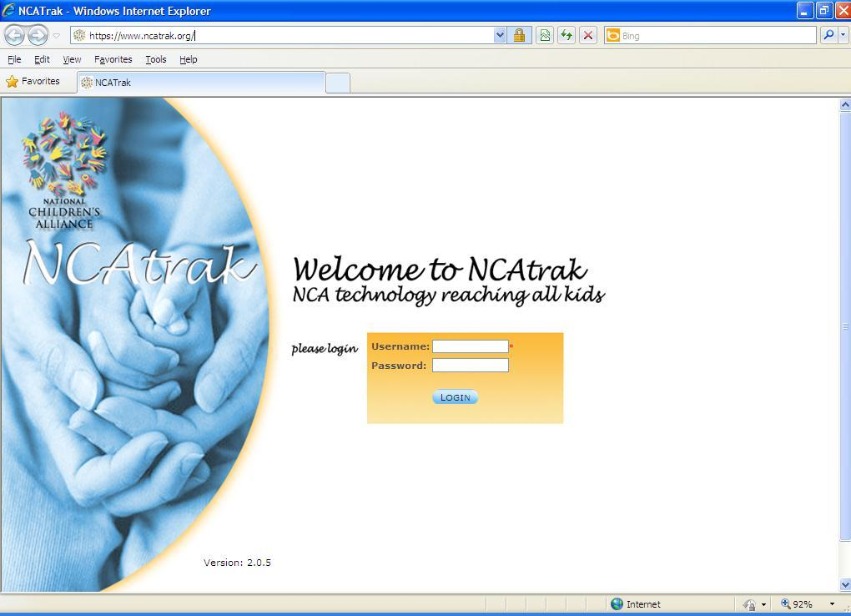
You will be prompted for your center’s log in credentials. The system will be activated for submissions and you will receive a personal email containing your organization's specific log in information two weeks prior to each deadline. If you haven’t received this email within the two weeks prior to the submission window, please contact Anette Regalado at ncatrakhelpdesk@nca-online.org .
NOTE: All of your center’s identification information inside the system is connected to this unique Username / Password combination. Make sure the information on your screen is exactly like it is in your email before clicking on ‘Login’. If you experience any problems logging in, please ask for assistance here: help form.

Step 2: Choose the Date Range
Confirm that the appropriate time period and year are correctly entered in the Period and Year fields. Then, click on the green ‘Enter Statistics Data’ button below these fields.
Step 3: Enter your data
Enter your statistics in the provided fields. Please remember that the system will log you out after 40 minutes of inactivity without saving your data. Please be ready with your data prior to beginning submission.
The Statistical Submission Screen
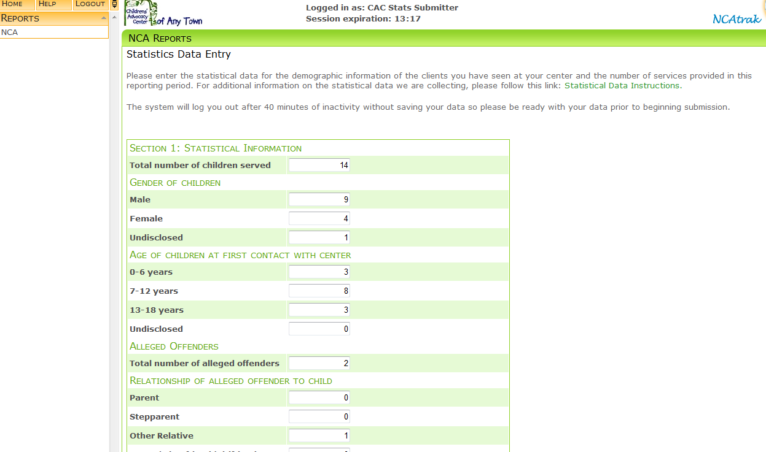
Special Note: You can only enter numbers into the fields in Sections 1 – 3 (Except for the ‘Other Services Provided’ question).

Complete the online form, paying special attention to the following sections (For an explanation of how to count the data for Section 1 and Section 2 see Appendix C):

Section 1: Enter the number of services and the demographic information for the children seen by your center. If NCA does not offer an option for “unknown”, please do not write that as an option on the form.

Question 1: Please enter the total number of new children served at the CAC this reporting period:
Note that this includes sexual abuse, physical abuse, neglect, drug endangerment, witness to violence and other forms of child maltreatment.

Question 2:
Please enter the gender of the new children served at the CAC this reporting period:
Female
Male

Question 3:
Please enter the ages of the new children served at the CAC this reporting period:
0 - 6 Years
7 - 12 Years
13 - 18 Years

Special Note: The sums for questions 1-3 must be identical. For example, if the center reports that 204 children were served in the reporting period, then the case details documented in 2 & 3 should also total 204.

Example:
Total number of new children served at the CAC this reporting period: 204
Gender of Children:
Female: 128
Male: 76
Total: 204
Age of children at first contact:
0-6 Years: 88
7-12 Years: 75
13-18 Years: 41
Total: 204

Special Note: This is the number of cases referred to your center during the reporting period which your CAC has been involved in the MDT response to an allegation of abuse. DO NOT INCLUDE referrals for services that are outside the core mission of your CAC – include these ‘Other’ services in the ‘Other Services’ section at the end of this form.

Question 4:
Please enter the total number of alleged offenders:

Question 5:
Please enter the breakdown of the relationship of alleged offenders to the new children served during the reporting period:
Parent
Stepparent
Other relative
Parent's boy / girlfriend
Other known person
Unknown relationship

Question 6:
Please enter the age of the alleged offenders from question number 4:
Under 13 Years
13 - 17 Years
18+ Years
Age unknown

Question 7:
Please enter the types of abuse reported for the new children served during the reporting period:
Sexual abuse
Physical abuse
Neglect
Witness to violence
Drug endangered
Other
Question 8:
Please enter the race or ethnicity of the new children served during the reporting period:
White
Black / African American
Hispanic / Latino
American Indian / Alaska Native
Asian / Pacific Islander
Other Race / Ethnicity

Special Note: The answer to the question 8 should equal the number you entered in the question 1.

Question 9:
Please enter the number of children receiving the following services during the reporting period:
Medical exams / treatment
Counseling / therapy
Referral to counseling / therapy
Onsite forensic interviewing
Offsite forensic interviewing

Special Note: The sum of the number entered in question 9 may be higher than the total number of new children that you entered in question 1. Question number 9 should reflect the total number of children served during the reporting period and not just the children involved in new cases referred to your center during the reporting period.

Section 2: Enter outcome information of cases
Special Note: Accredited programs, as noted in the NCA Standards for Accredited Members, are required to track outcome information. The statistical reporting form should be used and completed in its entirety by those members. While NCA recognizes Associate/Developing and Satellite Member programs may have challenges in tracking outcome information, we ask that you complete the information below to the best of your ability.

Question 10:
Please enter Child Protective Services disposition information. Specifically, the number of dispositions by the following categories:
Founded / reason to believe
Administrative closure
Moved
Unable to determine
Unfounded / ruled out
Other reason for closure

Special Note: Glossary of terms for the Child Protective Services Section of the form:

CPS refers to Child Protective Services. In your state this may be called Department of Children and Families, Department of Human Services or another name. We recognize CPS as a general term.

CPS outcome information:
Founded/Reason to believe: case that was investigated by CPS and the evidence substantiated abuse.
Administrative closure: case that does not meet criteria to be assigned.
Moved: case where the child/family has moved out of the service area.
Unable to determine: case that was investigated by CPS and the caseworker was unable to substantiate abuse.
Unfounded/Ruled Out: case that was investigated by CPS and no determination of abuse was made.

Special Note: Please only enter the Child Protective Services disposition information for cases (meeting the CAC’s case acceptance criteria) that CPS closed during the reporting period by the listed categories.

Question 11:
Please enter Law Enforcement dispositions information:
Number of cases where charges were filed

Question 12:
Please enter your Prosecution Disposition/Results. Specifically, please provide the below information:
Number of cases accepted for prosecution
Number of cases that resulted in convictions
Number of cases that resulted in pleas
Number of cases that resulted in acquittals
Special Note: For the purposes of this question, please count a case under ‘convictions’ if any of the charges connected to the case resulted in a conviction by jury / judge decision. Please count a case under ‘pleas’ if any of the charges connected to a case resulted in a conviction by a plea agreement. Please count a case under ‘acquittals’ if any of the charges connected to a case did not result in a conviction by jury / judge decision.

Section 3: CAC Information. These questions are included for DOJ reporting purposes regarding your CAC.

Question 1:
Total number of CAC/MDT staff members who received training in this reporting period
Special Note: This is regardless of funding source. Only numbers can be entered in this field.
Question 2:
Which of the accreditation standards you improved upon during this reporting period.
Standards as checkboxes 1-10
Question 3:
What improvements did you make at your CAC in this reporting period?
Add service
Expand existing service
Quality assurance activities
Question 4:
During this reporting period, did your numbers of clients served:
Stayed the same
Increase
Decrease
Question 5:
What is your organizational type?
Independent 501(c)3
Program under an umbrella organization that is a 501(c)3
Hospital based CAC
Prosecution/Government based CAC
Law Enforcement/Government based CAC
Child Protective Service/Government CAC
Other Government based CAC
Definitions of these organizational types may be found in Appendix B of this document.

Question 6:
Please choose the statement that best describes your physical location.
Our CAC has its own facility that is not shared with any partner agency
Our CAC is co-located with partner agencies
Question 6A:
If you choose “Our CAC is co-located with partner agencies” a new question will appear:
The organization/s we are co-located with are (Choose all that apply)
CPS
Law Enforcement
Hospital or Medical Services
Prosecution
Government Agencies
Independent Non-profits
Other
Question 7:
Enter what your CAC budget is.
$90,000 or less
$100,000 to $499,000
$500,000 and above

Question 8:
Enter if your CAC have an existing Interagency Agreement / MOU that included Native American Communities in your service area.
Yes
No

Other services: Please enter information about other services provided by CAC. Specifically, enter below the total number of services provided to individuals who were seen at the CAC in each category:
Case management / Coordination for children
Case management / Coordination for adults
Prevention services for children
Prevention services for adults

Special Note: Review the description of each type of service and follow the data entry instructions below.

1. Case Management/Coordination (services for children and/or adults) –
This refers to case coordination provided by the CAC for children who are not seen at the CAC. This may be for physical abuse cases or other types of cases that don’t present to the CAC. To enter your data:
a) Enter the number of children you have served in the text box under ‘Children’
b) Enter the number of adults you have served in the text box under ‘Adults’

2. Prevention –
a) Services for Children – We know that many CACs engage in prevention services for children. Some have formal programs in the school, others may have groups focused on prevention efforts, and others participate in collaborative community projects.
b) Services for Adults – This section is for those prevention services provided to adults. Like the prevention services for children, these may include specific programs in community centers, groups, or other forums.

3. Other Services Provided –
The 'Other Services Provided' category allows you to type in the nature of a service you would like to report and the number of individuals (broken down by child, adult or age unknown) who received that service. Simply enter a description of the service, the number serviced in the appropriate box and click save to the left of that line. Your information will be saved and a new line will be created. You can record an unlimited amount of ‘Other Services Provided.’

Special Note: Other services are those services provided by your center/agency that do not fit the description of case management or prevention services above. Examples are:
Adult Sexual Assault Exam
Community/Family Advocacy
Court Preparation/Advocacy
Court School Services
Crime Victim Compensation
Crisis Calls
Crisis Intervention
First Step
Foster Care Clinic
Hair Screens
Hospital Visits
Hotline Calls
Information/Referral
Public Education
Support Groups
Step 4: To submit your form, click ‘Submit to NCA’ at the bottom of the page. Please submit only once.

Special Note: Prior to submission NCAtrak will confirm that the sums of all appropriate fields equal before the submission is accepted. If the Statistical Submission Form appears after you have clicked on the ‘Submit to NCA’ button, scroll up and review the screen again – NCAtrak has uncovered an error.

You can print a copy of your submission for your files after submitting. On the initial landing page, use the green ‘View All NCA Report Submissions’ button.

Click the ‘View Submission’ link on the left of the screen next to the desired submission period. A new window will pop up with the information in a PDF document. Either print out this document for your records or click ‘Save’ on the top-left of the menu and save the file to your computer. NOTE: You will not have access to this page shortly after the submission deadline. It is strongly encouraged that you do keep a copy of this information for your records.

Step 5: SUBMISSION DEADLINE:
- Jan 15th of each calendar year- submission of July-December data.
- July 15th of each calendar year– submission of January-June data.
- Regardless of which day of the week the submission date falls on each year, the submission system is closing at 11:59 EST on the deadline.

Reports cannot be emailed, faxed, or mailed.

Your account will be activated for submissions and you will receive your log in information two weeks prior to each submission deadline.

Please feel free to submit your questions with this help form or call Jonathan Picklesimer at (202) 548-0090 extension 113. Thank you for all you do for the children.

*Only Satellite Members who are registered as Satellite Member with NCA are required to report statistics. Further, if the “parent” organization of the Satellite Member is an NCAtrak user, please contact ncatrakhelpdesk@nca-online.org.
Appendix A
Getting Ready To Submit Stats

There are a few items that you can do to help your stats submission go smoothly!

If you use a Windows Computer

- You can still use Internet Explorer (IE) to access NCAtrak. We recommend IE 9 or higher and if you are using IE, follow the next steps. If you are using Chrome, Firefox, Edge or Safari, no additional settings need to be set except possibly the pop-up blocker settings.
- Add ncatrak.org to your Compatibility View Settings. (Instructions at http://windows.microsoft.com/en-us/internet-explorer/use-compatibility-view#ie=ie-11)
- Add https://www.ncatrak.org to your list of trusted websites. (Instructions at http://windows.microsoft.com/en-us/windows/security-zones-adding-removing-websites#1TC=windows-7)
- Add https://www.ncatrak.org as an exception to your pop-up blocking rules (Instructions at http://www.sevenforums.com/tutorials/1679-internet-explorer-pop-up-blocker-exceptions-add-remove-website.html)
If you use a Mac Computer
- You can use Mozilla Firefox (Firefox) or Safari to access NCAtrak.
- Add https://www.ncatrak.org as an exception to your pop-up blocker rules. (Instructions at https://support.mozilla.org/en-US/kb/pop-blocker-settings-exceptions-troubleshooting)

Appendix B
Organizational Type Definitions

Organizational Type | Definition
Independent 501(c)3 | A non-profit organization with its own Board of Directors that does not function as part of another organization.
Program under an umbrella organization that is a 501(c)3 | A program that operates as part of a community services organization providing a range of services such as CAC, CASA, SART, DV intervention, etc. In this situation, the leader of the CAC typically reports to another person who is the Executive Director of a group of programs functioning as a non-profit.
Hospital based CAC | A program that is managed and operated under the direct supervision of a hospital.
Prosecution/Government based CAC | A program that is managed and operated from the prosecutor’s office of local/state government.
Law Enforcement/Government based CAC | A program that is managed and operated from a law enforcement branch of the local/state government.
Child Protective Service/Government CAC | A program that is managed and operated from a child protective services office/division of the local/state government.
Other Government based CAC | A program that is managed and operated as part of local/state governmental services but does not fit into one of the above categories.

Appendix C
Data Collection Detail

The tables below detail how the data in the statistical report are derived. The information labeled “Query” provides the specific requirements that must be met to be included in the count specified in bold print at the top of the table. The Case Tab columns and Data Fields columns indicate to NCAtrak users where the data being examined can be found in NCAtrak.

Total number of children served at the CAC during the reporting period
Query | Case Tab | Data Fields
Count of cases where the date the case was received by the CAC is within the reporting period, the reason for the referral is ‘allegation of abuse’, and the age of the alleged victim is <=18. | Presenting Tab | - Date Case Received by the CAC (within the reporting period)  - Reason for the Referral (allegation of abuse)
 | People Tab | - Role (alleged victim),  - Age at time of Referral (alleged victim’s age <=18)
If a child is the alleged victim on more than one case received by the CAC during the reporting period, the report will count both cases.

Gender of Children
Query | Case Tab | Data Fields
Count of cases where the date the case was received by the CAC is within the reporting period, the reason for the referral is 'allegation of abuse', and the age of the alleged victim is <=18, grouped by the alleged victim’s gender. | Presenting Tab | - Date Case Received by the CAC (within the reporting period)  - Reason for the Referral (allegation of abuse)
 | People Tab | - Role (alleged victim),  - Age at time of Referral (alleged victim’s age <=18)  - Gender (alleged victim’s gender)

Age of children at first contact with center
Query | Case Tab | Data Fields
Count of cases where the date the case was received by CAC is within the reporting period, the reason for the referral is ‘allegation of abuse’, and the age of the alleged victim is <=18, grouped by the alleged victim’s age. | Presenting Tab | - Date Case Received by the CAC (within the reporting period)  - Reason for the Referral (allegation of abuse)
 | People Tab | - Role (alleged victim),  - Age at time of Referral (alleged victim’s age <=18)

Total number of alleged offenders
Query | Case Tab | Data Fields
Count of alleged offenders on cases where the date the case was received by CAC is within the reporting period, the reason for the referral is 'allegation of abuse', and the age of the alleged victim is <=18. | Presenting Tab | - Date Case Received by the CAC (within the reporting period)  - Reason for the Referral (allegation of abuse)
 | People Tab | - Role (alleged victim),  - Age at time of Referral (alleged victim age <=18)  - Role (alleged offenders)

Relationship of alleged offender to child
Query | Case Tab | Data Fields
Count of alleged offenders on cases where the date the case was received by the CAC is within the reporting period, the reason for the referral is ‘allegation of abuse’, and the age of the alleged victim is <=18, grouped by the alleged offender’s relationship to the alleged victim. | Presenting Tab | - Date Case Received by the CAC (within the reporting period)  - Reason for the Referral (allegation of abuse)
 | People Tab | - Role (alleged victim),  - Age at time of Referral (alleged victim’s age <=18)  - Role (alleged offenders)  - Relationship to victim (matching NCA report terminology)  - People Tab – Alleged Offender Unknown (Checked)
This query will add one offender as ‘unknown’ for each case where the Alleged Offender Unknown checkbox is check. Your pick list terms for relationship to victim must each have a match to NCA report terminology on the pick list tab.

Age of alleged offenders
Query | Case Tab | Data Fields
Count of alleged offenders on cases where the date the case was received by the CAC is within the reporting period, the reason for the referral is 'allegation of abuse', and the age of the alleged victim is <=18, grouped by the alleged offender’s age. | Presenting Tab | - Date Case Received by the CAC (within the reporting period)  - Reason for the Referral (allegation of abuse)
 | People Tab | - Role (alleged victim),  - Age at time of Referral (alleged victim’s age <=18)  - Role (alleged offender)  - Age at time of Referral (alleged offender’s age <=18)

Type of abuse reported
Query | Case Tab | Data Fields
Count of cases where the date the case was received by the CAC date is within the reporting period, the reason for the referral is ‘allegation of abuse’, and the age of the alleged victim is <=18, grouped by the type of alleged maltreatment(s) identified at the time of the referral to the CAC. | Presenting Tab | - Date Case Received by the CAC (within the reporting period)  - Reason for the Referral (allegation of abuse)  - Presenting Tab – Alleged Maltreatment (matching NCA report terminology)
 | People Tab | - Role (alleged victim),  - Age at time of Referral (alleged victim’s age <=18)
When multiple alleged maltreatments are selected on a case, each will be included in the count. Your alleged maltreatment terms must each have a match to NCA report terminology on the pick list tab.

Race or ethnicity of total children seen at CAC during the reporting period
Query | Case Tab | Data Fields
Count of cases where the date the case was received by the CAC is within the reporting period, the reason for the referral is 'allegation of abuse', and the age of the alleged victim is <=18, grouped by the alleged victim’s race. | Presenting Tab | - Date Case Received by the CAC (within the reporting period)  - Reason for the Referral (allegation of abuse)
 | People Tab | - Role (alleged victim),  - Age at time of Referral (alleged victim’s age <=18)  - Race (for the alleged victim - matching NCA report terminology)
Your terms for race or ethnicity must each have a match to NCA report terminology on the pick list tab.

Medical Exams/Treatment
Query | Case Tab | Data Fields
Count of cases where the reason for the referral is ‘allegation of abuse’, and the age of the alleged victim is <=18, where there is at least (1) one attended Medical session during the reporting period. | Presenting Tab | - Reason for the Referral (allegation of abuse)
 | People Tab | - Role (alleged victim),  - Age at time of Referral (alleged victim’s age <=18)
 | Med Tab Session Log | - Date (within reporting period)  - Status (attended)
If a case has more than 1 attended Med session during the reporting period, this report will only count one.

Counseling Therapy
Query | Case Tab | Data Fields
Count of cases where the reason for the referral is ‘allegation of abuse’, and the age of the alleged victim is <=18, where there is at least (1) one attended Mental Health session during the reporting period. | Presenting Tab | - Reason for the Referral (allegation of abuse)
 | People Tab | - Role (alleged victim),  - Age at time of Referral (alleged victim’s age <=18)
 | MH Tab Session Log (Case Notes subtab) | - Date (within reporting period)  - Status (attended)
If a case has more than 1 attended MH session during the reporting period, this report will only count one.

Referral to Counseling Therapy
Query | Case Tab | Data Fields
Count of cases the reason for the referral is ‘allegation of abuse’, and the age of the alleged victim is <=18, where the ‘date therapy offered to the family’ is during the reporting period. | Presenting Tab | - Reason for the Referral (allegation of abuse)
 | People Tab | - Role (alleged victim),  - Age at time of Referral (alleged victim’s age <=18)
 | MH Tab – MH Provider Log | - Date Therapy Offered to Family (within reporting period)

Onsite/Offsite forensic Interviewing
Query | Case Tab | Data Fields
Count of cases where the reason for the referral is 'allegation of abuse', and the age of the alleged victim is <=18, where there is at least (1) one attended forensic interview session during the reporting period, grouped by location. | Presenting Tab | - Reason for the Referral (allegation of abuse)
 | People Tab | - Role (alleged victim),  - Age at time of Referral (alleged victim’s age <=18)
 | FI Tab Session Log | - Date (within reporting period)  - Status (attended)  - Location (matching NCA report terminology)
If a case has more than 1 attended FI session during the reporting period, this report will only count one. Your terms for FI Location must each have a match to NCA report terminology on the pick list tab.

Dispositions of Child Protective Services Information
Query | Case Tab | Data Fields
Count of cases where the reason for the referral is 'allegation of abuse', and the age of the alleged victim is <=18, where the CPS investigation closed date is during the reporting period, grouped by CPS dispositions. | Presenting Tab | - Reason for the Referral (allegation of abuse)
 | People Tab | - Role (alleged victim),  - Age at time of Referral (alleged victim’s age <=18)
 | CPS Tab | - Date Closed (within reporting period)  - Disposition - (matching NCA report terminology)
Your terms for dispositions must each have a match to NCA report terminology on the pick list tab.

Law Enforcement Dispositions – number of cases where charges were filed
Query | Case Tab | Data Fields
Count of cases where the reason for the referral is 'allegation of abuse', and the age of the alleged victim is <=18, where the LE investigation closed date is during the reporting period, and the ‘charges filed’ radio button is ‘yes’. | Presenting Tab | - Reason for the Referral (allegation of abuse)
 | People Tab | - Role (alleged victim),  - Age at time of Referral (alleged victim’s age <=18)
 | LE Tab | - Date Closed (within reporting period)  - Charges Filed (yes)

Cases accepted for prosecution
Query | Case Tab | Data Fields
Count of cases where the reason for the referral is 'allegation of abuse', and the age of the alleged victim is <=18, where the prosecution decision ‘review date’ is within the reporting period and the status is ‘accepted’. | Presenting Tab | - Reason for the Referral (allegation of abuse)
 | People Tab | - Role (alleged victim),  - Age at time of Referral (alleged victim’s age <=18)
 | Prosecution Tab -  Prosecution Decision | - Review Date (within reporting period)  - Status (accepted)

Convictions, Pleas, Acquittals
Query | Case Tab | Data Fields
Count of cases where the reason for the referral is 'allegation of abuse', and the age of the alleged victim is <=18, where the prosecution ‘outcome date’ is within the reporting period, grouped by prosecution ‘outcome’. | Presenting Tab | - Reason for the Referral (allegation of abuse)
 | People Tab | - Role (alleged victim),  - Age at time of Referral (alleged victim’s age <=18)
 | Prosecution Tab -  Prosecution Outcome | - Outcome Date (within reporting period)  - Outcome

Other services provided by CAC (tracked in NCAtrak)
Query | Case Tab | Data Fields
Count of attended FI, Med, VA, and MH sessions, and adjourned MDT meetings where the date of the session/meeting is during the reporting period and the reason for the referral on the case is ‘Other Direct Services’ or ‘Other Indirect Services’, grouped by ‘Other Direct Services and Other Indirect Services’, and age of person(s) receiving the service. | FI, Med, MH, VA Tab - Session Logs | - Date (within reporting period)  - Status (attended)
 | MDT Tab –  Meeting Results Log | - Date (within reporting period)  - Status (adjourned)
 | Presenting Tab | - Reason for Referral (Requesting Other Direct Services)  - Reason for Referral (Requesting Other Indirect Services)  - Other Direct Services / Indirect Services (matching NCA report terminology)
 | People Tab | - Role (Client)  - Age at time of referral (age of person who received service)
 | VA Tab Session Log | - Attendee
Your terms for Other Direct Services and Other Indirect Services must each have a match to NCA report terminology on the pick list tab. For FI, Med, MDT, and MH sessions, the attendee is the person whose role on the case is ‘client’. The report will count one service provided for each VA session attendee.

