National Children’s alliance

Your membership profile-did we get it right?
Dear Members,*
Please use the link below to update your organizational profile.
Update My CAC Profile
You can either …..
- Fill out the fields and “Review & Submit” at once or
- Start working on your profile and hit “Save & Finish Later”. Thus, your submission will be completed in multiple sessions. If you hit “Save & Finish Later”, you will receive an email with information on how to access your “saved but not submitted yet” profile again, later. The status of such submission in the system will be “In Progress”.
In such case, please do not use the link above to further access your “In Progress” application. ONLY use the link in the confirmation email message that will be sent to you. (See below an example of such email).

From: National Children's Alliance [mailto:mail@grantapplication.com]
Sent: Wednesday, June 22, 2016 9:39 PM
To: Irina Hein <ihein@nca-online.org>
Subject: Your Application in Progress
The information that you entered in your NCA grant application has been saved. However NCA does not have access to it because your application hasn't been submitted yet. The tracking number is 34992. Below is a copy of the contents you have entered so far. Please don't forget to finalize your application in progress by the deadline and submit it to NCA. In order to continue the work on your application, please use the link below https://www.GrantRequest.com/SID_1093 .
TIP: if you forget all of the above and end up with multiple profile applications open in your “In Progress Application” window because you clicked on the “Update my Profile link” more than once, figure out which one you want to keep and submit and delete the extra ones by clicking on the trash can on the left.

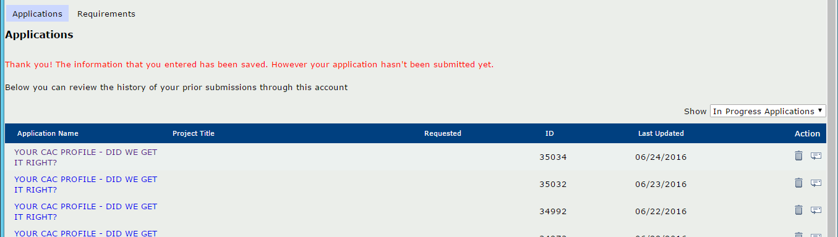

- While logged in your account, please select “Email Draft” in the top right corner of your page and send a copy of your filled out form to your chapter.

Thank you for all you do,
Member Relations & Grants Team
National Children’s Alliance

