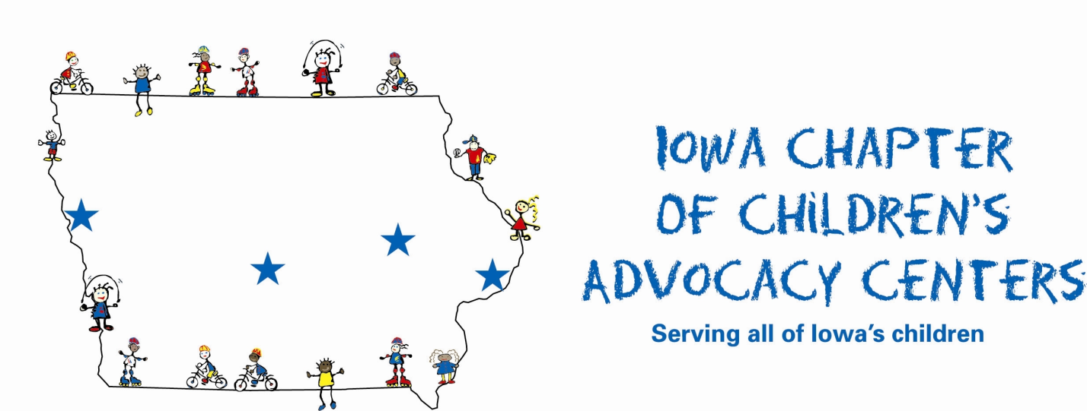
POSITION TITLE: EXECUTIVE DIRECTOR

REPORTS TO: Board of Directors

SUPERVISES: ICCAC staff

STATUS: Exempt

SUMMARY:

Under the authority of the Board of Directors, provide direction and oversight to the planning, development, and management of the ICCAC, which supports the needs of Children’s Advocacy Centers throughout Iowa. The Executive Director will organize state ICCAC activities, promote the concept of CAC’s, and develop public awareness at a state level. The Executive Director will encourage the development of new centers in interested communities and assist existing centers by coordinating, mentoring, and technical assistance efforts.

DUTIES AND RESPONSIBILITIES:

Coordinate strategic plan development and implementation for the ICCAC. Ensure smooth operation of the ICCAC including financial performance, budget preparation, staffing, marketing, program development, policy formulation and compliance with all pertinent government regulations and standards.

Coordinate and oversee all public policy activities, especially promoting CAC’s to legislators to acquire and sustain state funding.

Build relationships with and develop a thorough understanding of the status of all CACs in the state, from accredited centers to developing CAC’s and Multi-Disciplinary Teams (MDT’s). Serve as a central clearinghouse for information about centers in Iowa.

Network/collaborate with statewide and national organizations.

Assist the development of new CAC’s in Iowa with continued emphasis on maintenance and enhancement of existing centers.

Provide ongoing support to CAC’s as needed. Activities are not limited to, but can include the following: grant writing, site reviews, compliance checks, meeting accreditation standards, provide training, and other forms of support and advocacy to meet needs.

.

Work in conjunction with the Board and Membership to develop effective means of auditing, monitoring, evaluating and reviewing CAC’s to ensure compliance with standards.

Develop and secure approval of fiscal year budget and goals. Identify and develop additional sources to build a sustainable funding base for ICCAC. Write grant proposals, file and maintain appropriate reports and records. Assure donor records are maintained and updated.

Help create a strong sense of unity and cohesiveness among all CAC’s and MDT’s in Iowa.

Research funding for training opportunities and other needs of CAC’s and for the continued leadership development of the Executive Director.

Organize, schedule and attend all Chapter meetings/calls. Create agenda for Chapter meetings.

Act as Chapter liaison at local, state, regional and national meetings as appropriate.

Generate regular reports for the ICCAC Board of Directors on financial and program performance.

Other related responsibilities as designated by the ICCAC Board of Directors.

KNOWLEDGE, SKILLS, AND ABILITIES:

Excellent interpersonal skills and ability to work effectively with different constituencies

Excellent writing and verbal communication skills and a collaborative management approach

Strong organizational leadership skills and ability to manage multiple projects simultaneously

Self-starter with ability to work independently as well as in a team

Cross cultural competence and sensitivity

Computer and up-to-date technology skills

REQUIRED EDUCATION OR EXPERIENCE:

BA/BS or Master’s degree in relevant field with management and leadership experience in systems of child abuse investigation, prosecution and treatment

Engaging, energetic, independent personality traits with a high degree of commitment, strong organizational skills, consistent follow-through, self-motivation, and the ability to unite member agencies and professionals

Comprehensive knowledge of CAC’s and MDT’s as well as extensive knowledge of CACs and the dynamics of child abuse and maltreatment.

Experience in providing training and technical assistance in teaming, strategic planning and organizational development

Prior fundraising experience as well as extensive knowledge of CACs and the dynamics of child maltreatment

Proven success in grant writing and demonstrated writing and communication skills

Knowledge of local, state and federal legislative process

Experience in overseeing a regional, state or membership association

Strong skills in public relations, negotiations and budgeting are a must with the ability to work independently with flexible hours

A valid driver’s license and the willingness to travel

Must pass the equivalent of a federal background screening

SUPERVISION:

The Executive Director will be supervised by the Executive Committee of the Board

The BOD Executive Committee will be responsible for the annual evaluation of the Executive Director and measurement against stated duties. Additional input may be gathered from CAC directors.

